How to Request an online healthcare reimbursement
It’s easy to request a reimbursement from Marram. You can complete an e-form or post your request to the Marram office. Alternatively you can follow the simple process below and complete Marram’s online reimbursement request form.
That way you know the Marram team has your information straight away and it saves on paper and time!
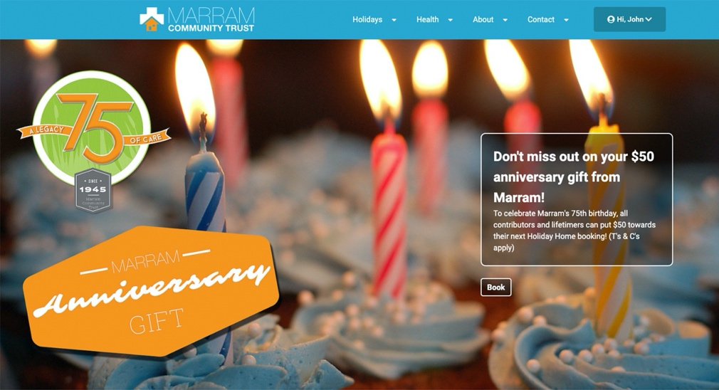
- You must be logged into the website to complete the online form. The login tab is found on the far right of the page menu.

- Once you’ve logged in navigate to your dashboard, using the drop down menu under your name and click on “My Healthcare Requests”
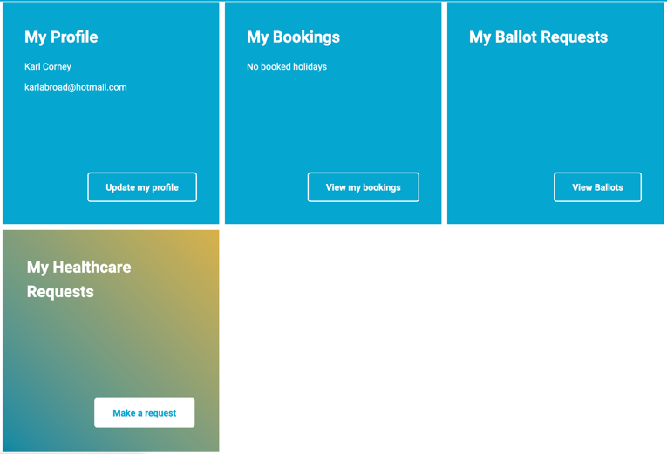
- This will bring you to the Healthcare reimbursement form. Complete all sections, with your details and information.
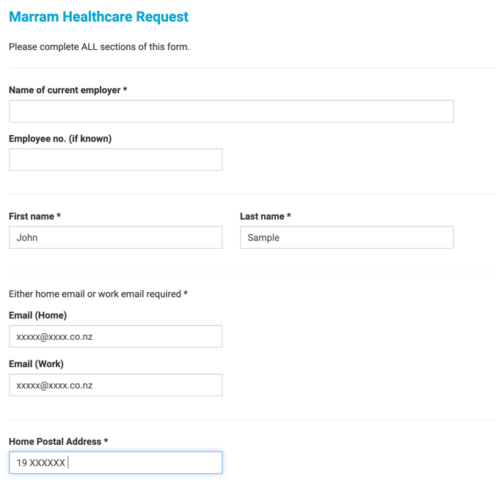
- Once complete please fill in the details of your healthcare treatment and costs. You will need to have digital copies of your receipts or invoices to upload them.
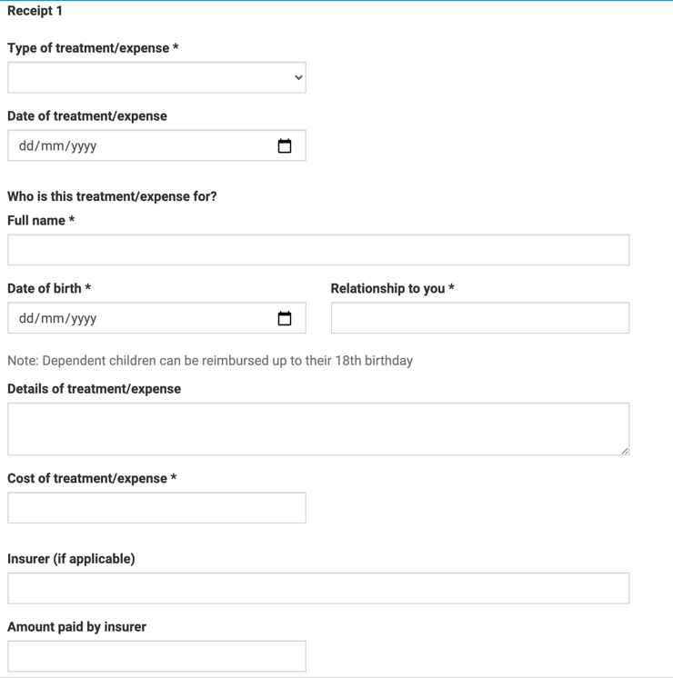
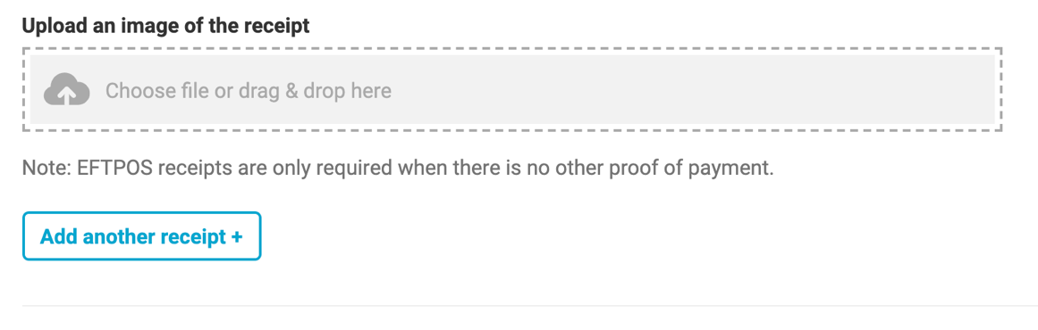
- If you complete the form on a mobile phone you will be able to use the phones camera to photograph the invoice or receipt.
- Tick the confirmation boxes to complete the form and hit submit. That’s it you’re done! The Marram team will process your request and contact you shortly.
